Section I: Scenario Demographics

Scenario Title: | Elderly End Of Life Care
Date of Development: | (18/04/2018)
Target Learning Group: | Juniors (PGY 1 – 2) Seniors (PGY ≥ 3) All Groups

Section II: Scenario Developers

Scenario Developer(s): | Professor Victoria Brazil, Dr Nemat Alsaba, Dr Rebecca Shaw
Affiliations/Institution(s): | The Gold Coast University Hospital, Gold Coast, Australia
Contact E-mail (optional): | Rebecca.shaw2@health.qld.gov.uk

Section III: Curriculum Integration

Learning Goals & Objectives

Educational Goal: | To practice goals of care planning in elderly patients in whom further life-saving interventions may not be beneficial, and to demonstrate compassionate and informative communication with care givers.
CRM Objectives: | - Demonstrate a sensitive end of life discussion in an ED context.  - Coordinate staff involved in management of a dying patient, including appropriate end-of-life care.
Medical Objectives: | - Recognize a patient in septic shock.  - Undertake a focused assessment as to benefits and harms of interventions to support life

References
http://onlinelibrary.wiley.com/doi/10.1111/1742-6723.12678/full
https://emcrit.org/emcrit/semantics-end-of-life-discussions/
https://www.smacc.net.au/2016/04/how-to-diagnose-dying-ashley-shreves/
Case Summary: Brief Summary of Case Progression and Major Events
An 89-year-old patient is brought in to the ED by ambulance from their nursing home. Staff found her unresponsive and hypotensive at morning handover. She had been treated for UTI by her family physician over the last few days. Participants identify severe sepsis and realize that critical care interventions may be inappropriate. This should prompt a goals of care discussion including potential for initiating end-of-life care.

Section IV: Scenario Script

A. Clinical Vignette: To Read Aloud at Beginning of Case
The charge nurse informs you “I just put a very unwell looking patient into resus. She’s from a nursing home facility and the paramedics think she is septic. She’s hypotensive and barely responsive. Honestly, she looks like she might be dying. Her granddaughter is on her way. I don’t think she has a known advanced care directive or code status.”

B. Scenario Cast & Realism
Patient: |  | Computerized Mannequin |  |  |  | Realism:  Select most important dimension(s) |  |  | Conceptual
 |  | Mannequin |  |  |  |  |  |  | Physical
 |  | Standardized Patient |  |  |  |  |  |  | Emotional/Experiential
 |  | Hybrid |  |  |  |  |  |  | Other:
 |  | Task Trainer |  |  |  |  |  |  | N/A
Confederates |  | Brief Description of Role
Patient |  | You are essentially moribund for this scenario. You have very cool peripheries (as demonstrated with ice) and look grey and ashen. Your mouth is wide open and your eyes are staring into space. You are breathing comfortably with an occasional mild cough.  You may be provided with oxygen, and/or IV fluids started. They may put your legs up and tilt the head of the bed down.
Patient’s granddaughter |  | You received a call from the home that your grandmother was very unwell and had been taken to hospital.  You kind of knew this day would come as it’s been a rocky past 6 months with her. She has been going downhill fast at the nursing home and no longer recognizes any of the family. She is intermittently aggressive and for the last week she hasn’t been eating or drinking anything.  No one has ever brought up her end-of-life wishes with you before, but in the back of your mind you did realize that she might die soon.  The GP said she had a urinary tract infection when he visited a couple of days ago and seemed to think that this is the reason she was off her food and prescribed some antibiotics.  Participants will be undertaking an initial assessment recognizing the severity of the patient’s condition. They will seek information from you, notes and other sources to determine cause and likely prognosis. Ideally, they will quickly engage in a discussion regarding the patients end of life wishes.  You really want to have this discussion at the patient bedside. You are a little surprised that the doctors seem to think the end is so near. You are relieved but kind of guilty that you are feeling relieved that she might die.  You don’t want her to suffer and feel bad about just ‘letting her die’. You ask if there is anything that can be done.  If the doctors ask what they think she would have wanted you are very clear that she would like to die peacefully and would not want any life support/ICU/ventilation or CPR.  If the doctors ask “what do you want us to do” you are less clear and suggest that you do want things done if they will help her.  The conversation ends with a plan to complete an “Allow Natural Death” Plan (also known as comfort care) to reflect and respect the wishes of the patient end of life care.
ED RN |  | Acts as an ED RN. Assists with bedside care of the patient. Provides initial handover.
C. Required Monitors
EKG Leads/Wires |  |  | Temperature Probe |  |  |  | Central Venous Line
NIBP Cuff |  |  | Defibrillator Pads |  |  |  | Capnography
Pulse Oximeter |  |  | Arterial Line |  |  |  | Other:
D. Required Equipment
Gloves |  |  | Nasal Prongs |  |  |  | Scalpel
Stethoscope |  |  | Venturi Mask |  |  |  | Tube Thoracostomy Kit
Defibrillator |  |  | Non-Rebreather Mask |  |  |  | Cricothyroidotomy Kit
IV Bags/Lines |  |  | Bag Valve Mask |  |  |  | Thoracotomy Kit
IV Push Medications |  |  | Laryngoscope |  |  |  | Central Line Kit
PO Tabs |  |  | Video Assisted Laryngoscope |  |  |  | Arterial Line Kit
Blood Products |  |  | ET Tubes |  |  |  | Other: Advanced Resuscitation Plan / Care of Dying Pathway
Intraosseous Set-up |  |  | LMA |  |  |  | Other:
E. Moulage
Standardized Patient. Grey and ashen looking with cool peripheries (may simulate with cool pack or ice). A cannula is in situ having been placed by the paramedics.

F. Approximate Timing
Set-Up: | 10 min |  |  | Scenario: | 20 min |  |  | Debriefing: |  | 20 min

Section V: Patient Data and Baseline State

A. Patient Profile and History
Patient Name: Sandra Thompson |  |  |  |  |  | Age: 89 |  |  |  |  |  |  | Weight: 55Kg
Gender: M F |  |  |  |  |  | Code Status: Requires discussion with family member, no previous code status documented.
Chief Complaint: Found unresponsive and hypotensive at nursing home morning rounds.
History of Presenting Illness: Has been treated for UTI by GP over the last few days
Past Medical History: |  | Hypertension |  |  |  |  | Medications: |  |  |  |  | Acetaminophen
 |  | Osteoporosis and previous left wrist fracture |  |  |  |  |  |  |  |  |  | Citalopram
 |  | UTI |  |  |  |  |  |  |  |  |  | Amlodipine
 |  | Depression |  |  |  |  |  |  |  |  |  | Amitriptyline at night
Allergies: No Known Drug Allergies
Social History: In nursing home facility. Was admitted there 6 months ago after a prolonged admission to hospital with delirium and sepsis, on a background of progressive cognitive decline.
Family History: N/A
Review of Systems: |  | CNS: |  |  | Patient is non communicative
 |  | HEENT: |  |  | Patient is non communicative
 |  | CVS: |  |  | Patient is non communicative
 |  | RESP: |  |  | Patient is non communicative
 |  | GI: |  |  | Patient is non communicative
 |  | GU: |  |  | Patient is non communicative
 |  | MSK: |  |  | Patient is non communicative |  |  |  |  | INT: |  |  |  | Patient is non communicative
B. Baseline Simulator State and Physical Exam
No Monitor Display |  |  |  | Monitor On, no data displayed |  |  |  |  |  |  | Monitor on Standard Display
HR: 90/min |  |  | BP: 62/40 |  |  |  |  | RR: 28/min |  |  |  |  |  |  | O₂SAT: 86% RA
Rhythm: sinus rhythm, broad complex |  |  | T:35.1 ºC |  |  |  |  | Glucose: 2.1mmol/L |  |  |  |  |  |  | GCS: 12 (E4 V2 M6)
General Status: Ashen and unwell looking. Minimally responsive
CNS: | Lethargic and moaning. PEARL 3mm
HEENT: | Nil
CVS: | Normal heart sounds. Wide complex sinus rhythm on ECG
RESP: | Shallow respirations. Decreased air entry to the right base with inspiratory crackles.
ABDO: | Soft and non-tender. BS present
GU: | Nil
MSK: | Nil |  |  |  |  |  |  |  | SKIN: | Cool peripheries

Scenario States, Modifiers and Triggers
Patient State | Patient Status | Learner Actions, Modifiers & Triggers to Move to Next State
1. Baseline State  Rhythm: sinus, broad complex  HR: 90/min  BP: 62 /40  RR: 28/min  O₂SAT: 86 %  T: 35.1ºC | Drowsy, moaning,  cool peripheries.  IV access already in place. | Learner Actions  - Collateral history and examination  - Applies monitors  - Ask about code/DNR status and attempt to speak to family  - ECG  - Check glucose (2.6)  - Labs, including critical VBG  - May give IV fluids, O2, dextrose, empiric calcium gluconate | Modifiers  Changes to patient condition based on learner action  - O2 applied sats 89%  - Dextrose given glucose 8.2  Triggers  For progression to next state  - All actions complete or 5 mins into case ED RN prompts that relative has arrived  2. Worsening Hemodynamics
2. Worsening hemodynamics  Rhythm: Sinus, wide complex  HR: 72/min  BP: 60/40  RR: 10/min  O₂SAT: 82 %  T: 35.1ºC | As above.  Family member discussion –  “How is she doing?”  “What kind of treatment does she need?”  “Can I stay with her?” | Learner Actions  - End of life discussion with family member/substitute decision maker  - Call social worker | Modifiers  - If participants attempt active management family member to state “she wouldn’t want all of this”  - If participants continue to attempt active management ED RN to prompt: “I think you better talk with the family member, it seems like she is really uncomfortable with what we are doing here”  Triggers  - Adequate discussion with family member completed  3. End of Life Care Planning
3. End of Life Care Planning | Patient status as above | Learner Actions  - Agreement on plans  - Communication of plans to team  - Prescribe medications for comfort (opioids, benzodiazepines, fan +/- glycopyrrolate) | Modifiers  - If no meds ordered for comfort, ED RN to prompt “Can you write up something for the pain and secretions?”  End Case PRN
Section VI: Scenario Progression

Section VII: Supporting Documents, Laboratory Results, & Multimedia
Laboratory Results
Na: 129 | K: 7.8 |  |  | Cl: 104 |  | HCO₃: 13 |  | BUN: 15.3 |  | Cr: 259 |  |  | Glu: 2.2
Ca: |  |  | Mg: |  |  |  | PO₄: |  |  |  | Albumin: 30
VBG |  | pH: 7.1 |  |  | PCO₂: 61 |  | PO₂: 70 |  | HCO₃: 13 |  |  | Lactate:9.0
WBC: 15.1 |  |  | Hg: 120 |  |  |  | Hct: |  |  |  | Plt: 150

Images (ECGs, CXRs, etc.)
ECG:
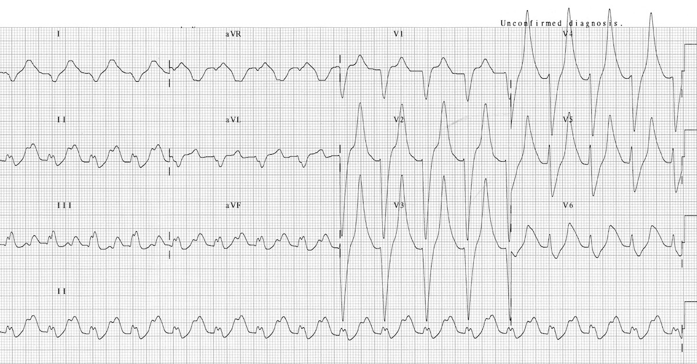
ECG source: https://litfl.com/hyperkalaemia-ecg-library/
CXR:
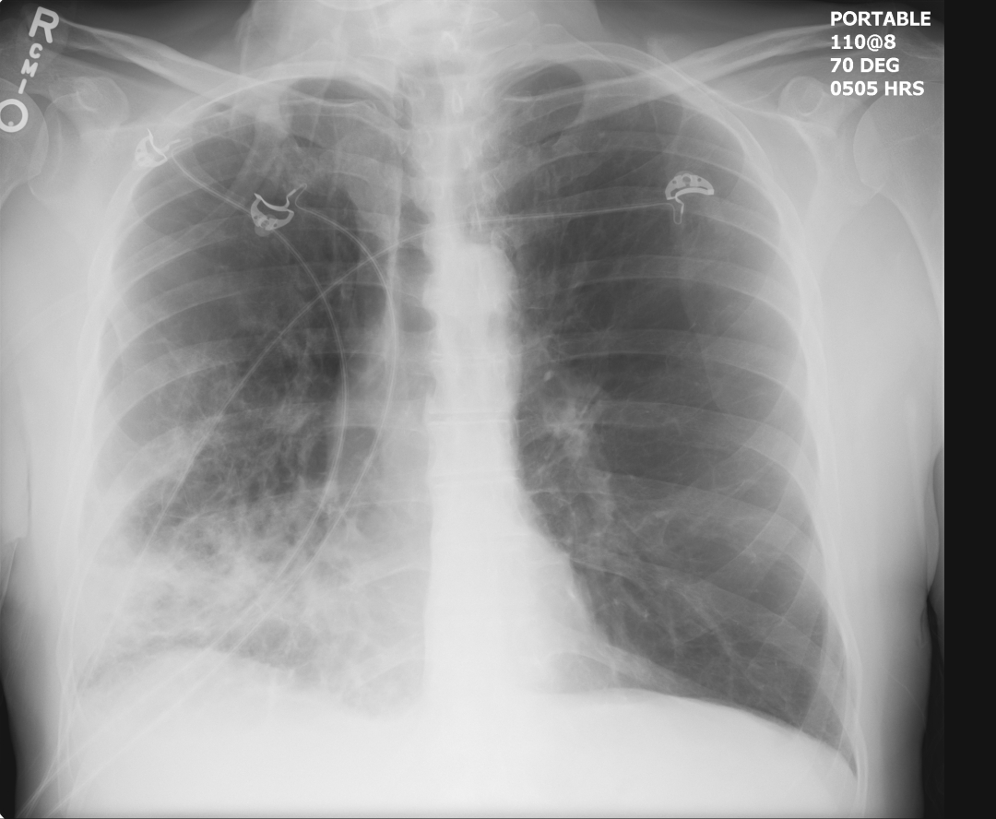
CXR source: https://emrems.com/2013/01/30/how-to-you-tell-its-a-right-middle-lobe-infiltrate/

Section VIII: Debriefing Guide

General Debriefing Plan
Individual | Group |  | With Video | Without Video
Objectives
Educational Goal: |  | To practice goals of care planning in elderly patients in whom further life-saving interventions may not be beneficial, and to demonstrate compassionate and informative communication with care givers.
CRM Objectives: |  | - Demonstrate a sensitive end of life discussion in an ED context.  - Coordinate staff involved in management of a dying patient, including appropriate end-of-life care.
Medical Objectives: |  | - Recognize a patient in septic shock.  - Undertake a focused assessment as to benefits and harms of interventions to support life
Sample Questions for Debriefing
- What factors influenced the decision that this patient was dying?
- What were the priorities for management in this dying patient?
- How did making the decision this patient was dying affect the team? Were all members of the team on the same page?
- How did it feel having an end of life discussion with the patients relative? What strategies did you utilize to communicate with this relative in a compassionate manner?
Key Moments
- Recognition of dying patient
- Discussion with relative regarding ceiling of care and end of life care.
- Implementation of end of life care

